

Location Tags

The work of creating interesting places and memorable campaign elements can be exhausting to a GM. Even when following the pattern provided in this book, the need to generate thumbnails of a dozen different cities, ruins, wilderness features, or other places of interest can frustrate and weary a creator. It becomes difficult to come up with new ideas about each new place or give them some sense of distinction.

***Tags*** are a creative tool meant to ease the GM’s bur­den by assigning each point of interest a pair of character­istic qualities or tropes. These two tags are then blended together and the result gives the GM a better idea of what the place is about and what kind of adventure op­portunities are to be found there. Each tag is made up of five different elements, each with three different examples provided.

***Enemies*** are antagonists characteristic of the trope. They’re exemplary villains or troublemakers that can be responsible for whatever unhappy situation exists that needs adventurers to help sort it out. They may not be the worst or more dangerous denizens of the place, but they’re vexing enough to make trouble for the natives.

***Friends*** are sympathetic or appealing NPCs that the players might be expected to want to help or coop­erate with. They’re the locals who are most likely to seek out adventurers for help or otherwise provide the hook for getting involved in a situation. The examples provide likely Friends for each tag, but the GM can tweak them to better suit the known interests and inclinations of the players.

***Complications*** are particular twists or difficulties that are characteristic of the trope. They may be partial inversions of the tag, or complexities that it layers onto a situation, or subversions of likely player expectations. Complications are meant to keep problems from being too straightforward and simply resolved without having to deal with the complexities of the place.

***Things*** are macguffins, treasures, rewards, or plun­der that might be found at the site, objects that the Ene­mies or Friends might be fighting over or that might be part of a Complication’s entanglements. While a pile of loot is usually enough to catch the eye of any adventurer, a Thing is something specific to the tag’s theme.

***Places*** are archetypal locations or characteristic structures for the tag, the kind of places you’d expect to adventure in were you in such a place. Other Places can be used as thematic backdrops for an adventure.

For each point of interest, two tags are rolled and the results are synthesized together when the GM needs a component for their adventure creation. If the tags for a community are Brilliant Innovation and Lawless Class and the GM needs an antagonist, they might pick “Cru­elly indulgent elite” and “Grasping guildmaster” from those tags’ Enemies lists and blend them together. Thus emerges Theophilus Crane, the ruthless, selfish Thurian guildmaster of the Arcanocaloric Guild, whose crucial advances in repairing thermal Workings have made him and his guildmates above the law in his native city. In the same vein, the “visionary supporter of the innovator” and “victim of an unpunishable crime” elements of the Friends lists can be turned into Hubert Wheelwright, Crane’s brilliant apprentice and the true originator of the tech­niques that Crane stole, now hiding in terror from his former master’s hired assassins.

Whenever you need some set dressing or adventure components for your points of interest, just go to the tags and mix up something that fits them. Some tags will be harder to mesh than others, of course. You could simply reroll them, or instead take some time to figure out a way in which the results actually do apply. Another option is to read one or both of the tags metaphorically, translating the general concept into terms applicable to the situation.

There are four different sets of tags in this section, each one aimed at a different kind of point of interest. While the sets are all aimed at their particular targets, it’s quite possible for a GM to mix and match out of any of the sections, either reading them metaphorically or com­ing up with novel explanations for a literal interpretation. GMs who have access to other Sine Nomine games that involve tags, such as Stars Without Number, should feel free to mix them in as well if they want additional grist.

***Community tags*** are for cities, villages, tribes, sub­terranean survivor bands, or other broad grouping of people. They give traits that distinguish the community from others like it; they may gesture at its organization or social structure, but the point is to explain what about the place might provide adventure grist for the GM.

***Court tags*** are for noble courts, temple hierarchies, business enterprises, dynastic families, insular clans, or other groups where intrigue, personal relationships, and conflicting goals are apt to be found. People in a court want things and they’re likely to be looking to recruit outsiders to help.

***Ruin tags*** are for classical dungeons, lost cities, Outsider ruins, mysterious towers, or other sites where sneaking down corridors and checking for traps are usual adventurer pastimes. They’ll help you add flavor to your holes in the ground or piles of cracked masonry.

***Wilderness tags*** are for natural hazards, dangerous lands, remote motherlodes, wild beast territories, and other sorts of encounters or points of interest that might draw an adventurer’s attention. They’re often useful in filling up a hexcrawl, allowing a GM to plant points of interest in the deep wilderness without having to load it up with an endless parade of villages or minor dungeons.

Each section provides some additional tables and guidance, the better to assist you in using the tags to their full effect. As always, you should take what you need from those tools, using only the ones that you need and adjusting things as your creativity recommends.

Communities

While Courts provide tightly-connected webs of rela­tionships for the PCs to entangle themselves in, Commu­nities serve more as adventure backdrops for the heroes, or contexts in which other adventures occur. The partic­ular heroics of the party might significantly change the Community, and the needs and situations of the place might present immediate adventure hooks to them, but the existence of a market town does not serve as the same blatant predicate for adventure that a lost Deep offers.

Most often, Communities serve as the sandboxes in which urban-focused or intrigue-based adventures can occur. For many players, the default mode of interaction in the wilderness or the underworld is combat; in a city or village, that default instinct is going to be conversation. Sudden, brutal violence is by no means alien to a city, but most PCs will be much less inclined to pull their swords on a surly town guardsman than on an Anak warrior.

The resources in this section include both a list of Community tags and a set of tables that can be used to flesh out and characterize particular settlements. While you could optionally choose to use one, both, or neither, they’re built to work cooperatively.

To characterize the Community, decide whether it’s best considered a rural village, a significant city, or a tribal or provisional gathering of people. Using the appropriate table, find out the basic rationale for the settlement’s ex­istence first; this will tell you a great deal about the kind of locals you’ll be finding in the Community and what their chief employments and interests are likely to be.

From there, you can roll or pick to find out who ac­tually runs the Community. This may or may not be the nominal head. The central government might say that the leader of a farming hamlet is the government-appointed headman, but everyone in the village might know that Mother Orde is the one who decides what they’re going to do when a problem arises. Tension between real and nominal leadership can make for useful adventure grist.

The “significant locals” column can be used to gener­ate a few NPC hooks for those occasions when you need a suitable local face for your adventure or an NPC you can hang a hook on. The “current pressing problem” is an immediate situation you can color with Community tags or use straight. If you mean to make an adventure hook out of it, be sure it’s something the PCs can reasonably influence with their involvement.

For delivery of adventure hooks, the two bottom tables suggest potential local NPCs who might approach the party and some ideas for what the natives could offer by way of payment. These suggestions will be colored by the Community tags and the Friends or Things that are suitable to the Community’s situation. As with all the ta­bles, they should be taken as suggestions for you to shape.

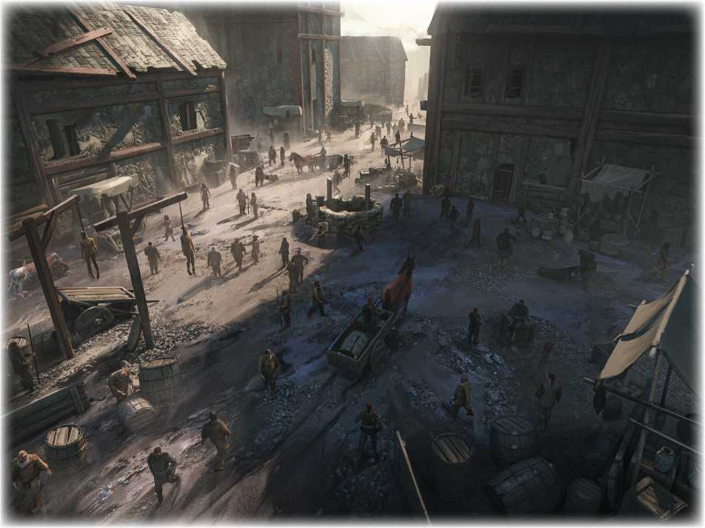

Rural Villages

These tools can be used for the typical medieval-flavored village or rural hamlet beloved of many adventures. Such places are at usually at least minimally self-sufficient. Vil­lages in relatively sophisticated nations might have per­manent shops or full-time artisans working a particular trade, but most such hamlets have their entire population engaged in agriculture, with specialists doing particular crafting jobs as their neighbors might need them. Coin­age is usually scarce and reserved for use with outside tax collectors and hired workers, as the local trade deals in tacitly-understood favors owed and granted.

While such villages are often very poor, it’s not un­known for them to have at least some valuable goods or trades hindered by the village’s great remoteness, com­plete lack of fame, or inability to safely get the good to a market that has a demand for it.

d12 Rationale for the Village’s Existence

1. Once a garrison outpost of a nation
2. A mine or quarry, perhaps now exhausted
3. A spot where refugees of a calamity settled
4. Holy ground or a temple to a particular faith
5. A plant or animal grows very well here
6. It’s a safe waypost on a trade route
7. Refuge for a despised minority or group
8. A bandit camp that went legitimate
9. A self-ruled home for demihuman residents
10. It’s a safe base for salvage or ruin plundering
11. Decayed remnant of an ancient city
12. It grew up around a lordly manor or estate

**Features of the Village**

|  |  |  |  |
| --- | --- | --- | --- |
| **d12** | **Who Runs It?** | **Significant Locals** | **A Current Pressing Problem** |
| **1** | A hereditary headman | The village harlot | Vital food stores have been lost or stolen |
| **2** | A reeve picked by a lord | The worst local bully | Two families are in a long-running feud |
| **3** | A temple representative | A gifted young peasant | A new religion is making trouble with the old |
| **4** | A council of elders | A half-savage shepherd | The lord’s reeve has been given unreasonable quotas |
| **5** | A cruel and feared bully | A charismatic priest | An upstart newcomer is disrupting the native hierarchy |
| **6** | A popularly-chosen chief | A major landowner | A socially marginal family is suspected of crimes |
| **7** | A dreaded sorcerer | A youth who wants out | A dangerous beast or foe is lurking near the place |
| **8** | A pragmatic warlord | Venerable old farmer | A local bully and his friends are causing trouble |
| **9** | The richest native there | Criminal in rural hiding | The crops or herds are in very poor condition |
| **10** | A traditional squire | Native hedge mage | An ambiguous land dispute is getting bloody |
| **11** | A patriarch or matriarch | A noble’s local reeve | A curse or magical woe is vexing the people |
| **12** | An organization’s envoy | Important artisan | Noble quarrels have caused collateral damage |

**Village Involvements with Adventurers**

|  |  |  |
| --- | --- | --- |
| **d12** | **Local Likely to Interact with Adventurers** | **Interesting Things the Place Can Offer Heroes** |
| **1** | An ambitious local who wants to get to the city | An unusually large amount of saved coinage |
| **2** | Social outcast who can’t ask any local for help | Valuable local specialty product |
| **3** | Gentry who wants no local gossip about their need | Heirloom magic item passed down to the leader |
| **4** | Ex-city dweller eager for contact with the worldly | A magical service unique to a local tradition |
| **5** | Comparatively rich villager with a need | A map or secret leading to a Deep or plunder site |
| **6** | Starry-eyed young local swooning for adventurers | A temple with potent healing magics available |
| **7** | Village priest in need of outside help | A secret treasure acquired generations ago |
| **8** | Reeve who can’t reasonably call on natives for a job | Large amounts of produce or local products |
| **9** | Village leader who wants expendable help | Ownership of an abandoned farm or structure |
| **10** | Burly local militiaman who watches new faces here | Contacts with rural bandits or criminal rings |
| **11** | Shifty native who wants some clueless accomplices | Favors from the lord who’s very fond of the village |

**12** Clan patriarch who doesn’t want to use their own kin Young locals willing to take service with the party

Major Cities

A village is largely self-sufficient and organized around the production of basic necessities. A city, whether a market town or a grand megalopolis, is a place that lives off the produce of tributary communities and produces goods and services of a sophistication far beyond that possible in a small village. These tables can be used for modest market centers or major urban sites, with details being scaled to fit the size of the city.

Cities need a constant flow of food from the sur­rounding countryside, and not uncommonly a constant flow of new citizens from the villages to make up for the death rate brought about by plagues, malnutrition, and endemic diseases. Only the richest and most advanced urban centers can escape this entropic drain, often with the help of still-operational ancient Workings. Cities are the places most likely to still maintain these great edifices.

d12 Rationale for the City’s Existence

1. It’s the former seat of a vanished nation
2. It’s a trade nexus that has greatly prospered
3. It’s an industrial or productive center
4. There is heavy resource extraction nearby
5. It controls a vital defensive point
6. It’s built around an ancient Working
7. It’s a stronghold of a local subculture
8. It’s a sacred city to an important faith
9. It’s a shared market for many villages
10. It’s a place of great beauty or healthfulness
11. It’s a shelter from dangerous environs
12. The natives are somehow bound here

**Features of the City**

|  |  |  |  |
| --- | --- | --- | --- |
| **d12** | **Who Runs It?** | **Significant Locals** | **A Current Pressing Problem** |
| **1** | Hereditary lord | Sinister crime boss | Raiders are scourging local trade routes |
| **2** | Merchant prince | Head of a major temple | Criminals have corrupted the local law enforcement |
| **3** | Council of oligarchs | Neighborhood patriarch | Displeased locals are rioting for some reason |
| **4** | Allied noble heads | Ethnic group elder | The king or local ruler is making harsh demands |
| **5** | Royal viceroy | Rich merchant | Food supplies aren’t being received as they should |
| **6** | Gentry-elected mayor | Feared local mage | Urban groups are arming to resolve some dire conflict |
| **7** | Major clerical figure | City watch chief | A recent calamity has done major infrastructure damage |
| **8** | Occult power wielder | Decadent noble | A disguised monster is feeding on the city from within |
| **9** | Criminal group catspaw | Local magistrate | The rulers have gravely offended a local religion |
| **10** | Ethnic group’s ruler | Outcast group leader | A rebel group denounces the city leader’s legitimacy |
| **11** | Chief magistrate | Famous courtesan | A private war threatens with another major city |
| **12** | Military strongman | Demihuman enclave head | A major local industry is threatened by events |

**City Involvements with Adventurers**

|  |  |  |
| --- | --- | --- |
| **d12** | **Local Likely to Interact with Adventurers** | **Interesting Things the Place Can Offer Heroes** |
| **1** | City official looking for deniable agents | Large amounts of conventional coinage |
| **2** | Wealthy merchant who wants unknown outside help | Expensive urban property |
| **3** | Newcomer peasant haplessly looking for assistance | Sophisticated and very valuable local products |
| **4** | Demimonde navigator always watching for clients | Formal citizenship and the rights of a local |
| **5** | Curious urchin who trades in local news and events | Quiet dismissal of criminal charges or sinister pasts |
| **6** | Criminal with a mind to use naive newcomers | Indulgences beyond the power a smaller place to grant |
| **7** | Desperate merchant trying to keep their business going | Services of exceptionally skilled specialist professionals |
| **8** | Guard chief suspicious of potential troublemakers | Connections with major nobility of the realm |
| **9** | Native too infamous for other locals to deal with them | Absentee ownership of rural villages or manors |
| **10** | Noble who thinks adventurers will do anything for coin | Rare occult components or magical products |
| **11** | Slumming young gentry with a taste for excitement | Blessings from major clergy or high priests |

**12** Foreigner looking for fellow strangers to help

Business monopolies or tax rights in certain areas

Tribes and Exiles

Not all communities are neatly delineated by fields and city walls. Nomadic tribes, scruffy bandit camps, groups of underground Deep survivors, or Blighted warbands all constitute communities. They may be far poorer and more materially primitive than even a farming village, but they have some sort of social structure and self-identi­ty. While some may be violent by nature or habit, more peaceful interactions are usually possible for PCs.

These tables are meant for the sort of barbarian tri­bals, desperate bandit dregs, and subterranean survivors that an adventuring band is likely to run into at some point in their travels. The basic dynamics of these societ­ies are usually similar, ones based on raw force, personal charisma, and the prospect of plunder or good hunting. Particular roles or details can be reskinned to fit the spe­cifics of the tribe and its environment.

d 12 Why Are They Staying Here?

1. It’s an unusually well-fortified safe place
2. A charismatic leader bound them together
3. The hunting or resources are very good here
4. They were driven here by a dire enemy
5. Seers or shamans said it was ordained
6. The leadership wants to find something here
7. Their herds or prey have led them here
8. They’ve been trapped here by the situation
9. They’re paralyzed by internal dissent
10. They’ve been paid or induced to be here
11. Tradition requires they come here
12. Here they can do the most damage to a foe

|  |  |  |  |
| --- | --- | --- | --- |
| **d12** | **Who Runs It?** | **Significant Locals** | **A Current Pressing Problem** |
| **1** | Bestially savage tyrant | Best hunter in the tribe | The leader is becoming weak or acting foolishly |
| **2** | Wizened elder | Wise man or woman | A settled group is hunting them as mortal foes |
| **3** | Magically-gifted chief | Seer or shaman | A curse has been laid on them for some collective sin |
| **4** | Holy man or woman | Tribal artisan | They killed someone who had very powerful allies |
| **5** | Hereditary chieftain | Skilled scout | They’re impoverished and can’t reach new resources |
| **6** | Outsider or alien lord | Trader with outsiders | A fearsome beast hunts them in the wilds |
| **7** | Brutal but cunning chief | Adopted member | Their gods are sending dire but obscure omens to them |
| **8** | Foreigner turned ruler | Tribal slave | The tribe threatens to split under some feud or quarrel |
| **9** | Council of the elders | Feared troublemaker | Some are seeking a redder, more powerful god to serve |
| **10** | No ruler past clan heads | Tribe’s most eligible youth | A patron power is using them as expendable fodder |
| **11** | Envoy of a patron power | Barely-tolerated wretch | A sickness is raging through the tribe |
| **12** | Most charismatic native | Cunning tribal advisor | A rival group has taken over their hunting grounds |

**Features of the Tribe**

|  |  |  |
| --- | --- | --- |
| **d12** | **Local Likely to Interact with Adventurers** | **Interesting Things the Place Can Offer Heroes** |
| **1** | Raid-taken slave looking for a way back home | Guidance and safe passage through their territory |
| **2** | Leader with a natural suspicion about outsiders | Knowledge of a hidden place of wealth |
| **3** | Low-status native trying to acquire outside support | Exotic and valuable tribal goods |
| **4** | Tribal sage who likes news of the outside world | Plunder taken from a foreigner they’ve killed |
| **5** | Curious young tribal interested in strangers | Inherited relic or treasure they’ve kept |
| **6** | Near-outcast who wants a hand with some revenge | Secret for accessing an otherwise sealed place |
| **7** | Envoy of another group suspicious of other influences | Loot won in battle against another group |
| **8** | Tribal notable who suspects the PCs as potential rivals | They’ll raid the party’s enemies for a share of the loot |
| **9** | Tribal trader who wants access to outside goods | A magical elixir or substance they know how to make |
| **10** | Youth determined to show how tribal ways are best | Tribal membership and a place of respect |
| **11** | Eligible native looking for new blood in a mate | Slaves they’ve taken in raids or tribal wars |
| **12** | Reformer or innovator whose kindred won’t listen | Some young tribals willing to go with the party |

**Tribal Involvements with Adventurers**

